- Go to this website: https://moodle.concordia.ca/moodle/course/view.php?id=133938

- Click “Log in”

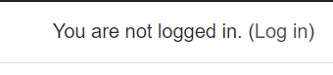
- Choose “Red box”
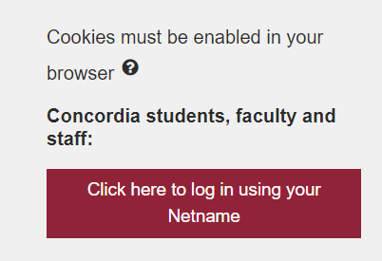

- Use password: Hhoxb86UI3
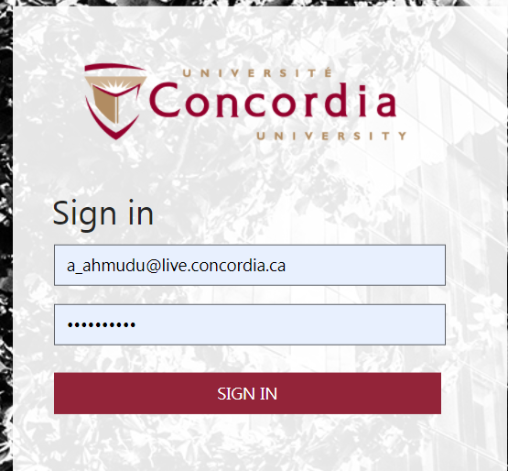
- Choose Econ 201
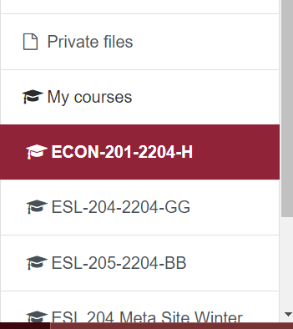

- Choose “Lynx Assignments”
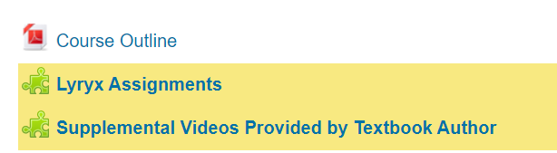

- Choose Assignments 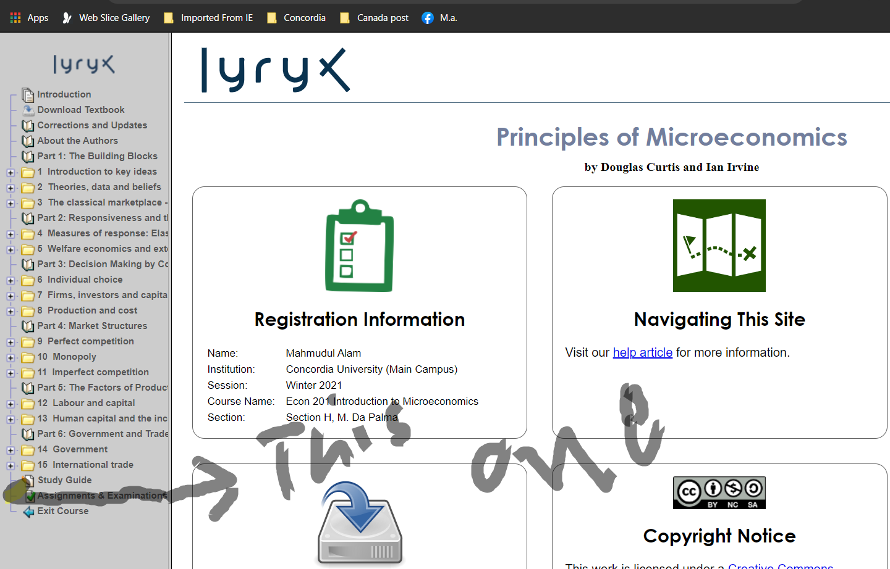

- And answer only Lab 3 and 4
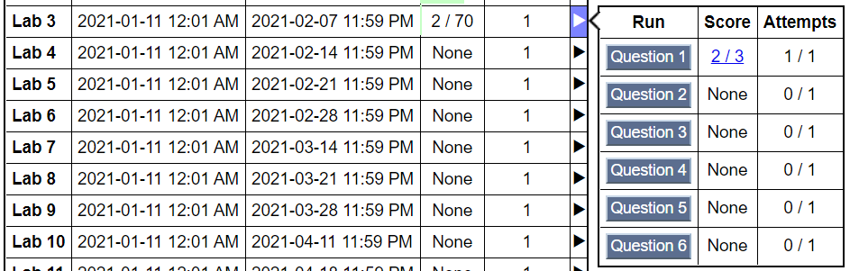

Note: out of 67 if you help me to score 60 I will give you $10 bonus, 55 will be $5 bonus and anything less than 45 I will cancel the assignment and will not pay.

